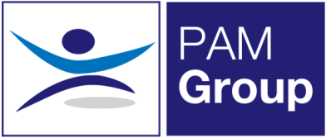


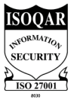
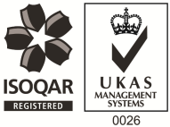
Occupational Health Advisor – Folkestone – Full or Part-Time

Competitive Salary + Car Allowance - Competitive Benefits Package
PAM OH Solutions is looking to employ an experienced Occupational Health Advisor on a part-time basis to provide services at our clinic in Folkestone. This post will also involve travel to surrounding areas in Kent including Dover and Canterbury. The post will be working 3, 4 or 5 days per week. The successful candidate will be responsible for pro-active Sickness Absence Management of short and long term absence cases, both face to face and via telephone consultations.
Working as an Occupational Health Advisor will involve:
- Advising on phased return to work programmes.
- Conducting Health Assessments, reporting on the outcomes within agreed timescales and to PAM OH standards, policies and procedures and NMC guidelines.
- Managing Health Records ensuring safe storage, security and confidentiality of all OH records, at all times complying with relevant legislation and good practice.
- Produces management reports as required.
- Actively promotes fitness for work, both preventative and rehabilitative, raising the profile of OH amongst all levels of employees and management.
- Supports the Businesses in reducing absence and improving their people potential at all times.
- Provides clear pragmatic advice to clients and employees that adds value to their decision making
- Seeks continuous improvement in the service provided, identifying opportunities to develop the function and proposing improvements and suggestions for continuous improvement.
- Attending meetings with client HR and Health and Safety teams

The ideal candidate will have the following:

- Registered General Nurse
- Hold a valid NMC Pin
- Hold or be working towards an Occupational Health Qualification, either certificate, degree or diploma
- Have experience of working with an Occupational Health role, preferably as an advisor
- Effective Report Writing Skills
- Excellent Communication skills

The benefits package includes:

- Pension Scheme
- Health Scheme
- Life Insurance Scheme
- 33 Days Leave Including Bank Holidays pro-rata for part-time hours
- Car Allowance
- NMC registration

This role would suit someone currently working as an Occupational Health Advisor or Trainee, apply now!

