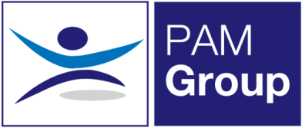

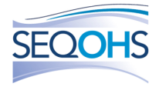
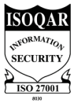
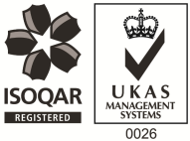
Occupational Health Advisor – Home Based with Travel – Full or Part-Time

Competitive Salary + Competitive Benefits Package
PAM Group Ltd is looking to employ an experienced Occupational Health Advisor to be home based doing a mixture of telephone consultations, with local client site visits to undertake case management. The post can be on a full or part-time basis, working 3, 4 or 5 days per week. This role is home based, however there will a requirement to travel once or maybe twice a week to sites in surrounding areas. The rest of your time will be spent working from home.
The successful candidate will be responsible for pro-active Sickness Absence Management of short and long term absence cases, either by home based telephone consultations or face to face appointments.
The role will involve:
• Advising on phased return to work programmes
• Conducting Health Assessments, reporting on the outcomes within agreed timescales and to PAM Occupational Health standards, policies and procedures and NMC guidelines.
• Managing Health Records ensuring safe storage, security and confidentiality of all OH records, at all times complying with relevant legislation and good practice.
• Producing comprehensive and effective management reports as required.
• Actively promotes fitness for work, both preventative and rehabilitative, raising the profile of OH amongst all levels of employees and management.
• Supporting the Businesses in reducing absence and improving their people potential at all times.
• Providing clear pragmatic advice to clients and employees that adds value to their decision making
• Seeking continuous improvement in the service provided, identifying opportunities to develop the function and proposing improvements and suggestions for continuous improvement.
• Attending meetings with client HR and Health and Safety teams

The ideal candidate will have the following:
• You must be a registered general nurse and hold a valid NMC Pin
• Hold or be working towards an Occupational Health Qualification, either certificate, degree or diploma
• You must be comfortable undertaking home based work and have an appropriate work space
• Have experience of working with an Occupational Health role
• Effective Report Writing Skills
• Excellent Communication skills

The benefits package includes:
• Pension Scheme
• Health Scheme
• Life Insurance Scheme
• 33 Days Leave Including Bank Holidays
• Mileage Allowance
• NMC Registration

This role would suit someone who is looking for a home based role which still includes face-to-face work. If you feel this vacancy would be suitable for you – apply now!

